1. Create project

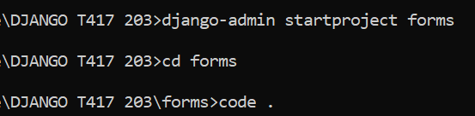

1. Create 3 applications

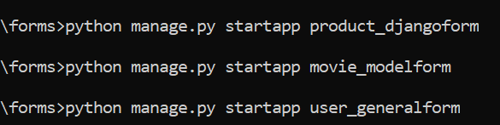

1. Register applications in settings.py

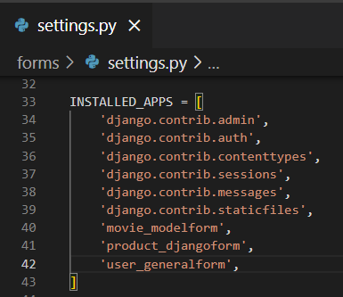

1. Create templates folder with following structure

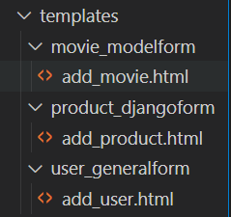

1. Register templates folder in settings.py

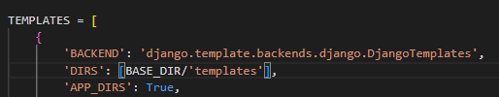

1. Create database forms

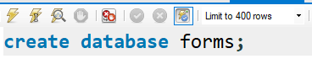

1. Register database in settings.py

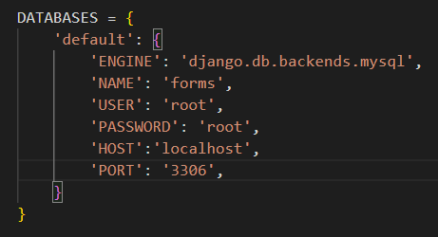

1. Create model in each application

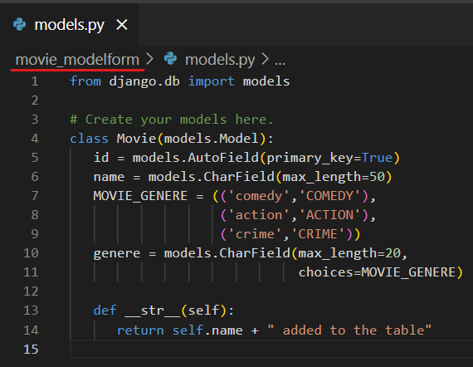 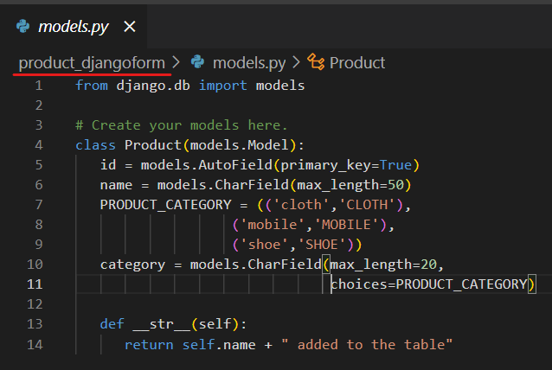

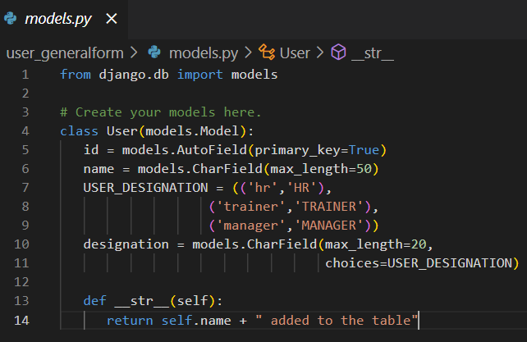

1. Register model of each application in admin.py

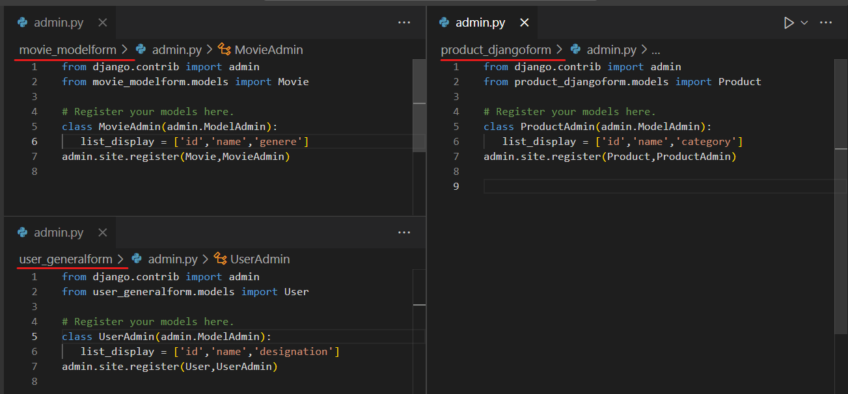

1. Makemigrations and migrate

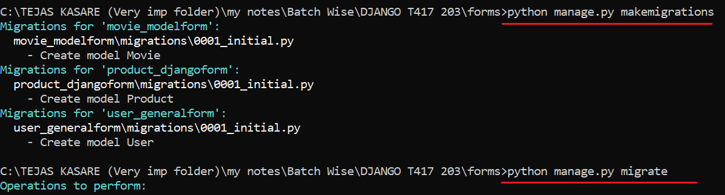

1. Check tables

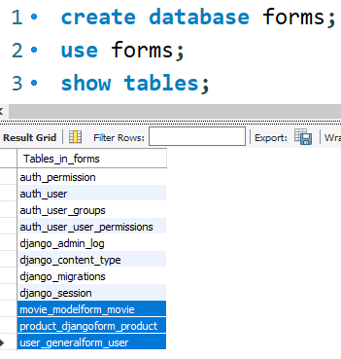

1. Working with django form

Since we are creating django form in Product application, bellow step are for application - product_djangofrom

* 1. Create forms.py in product_djangoform application

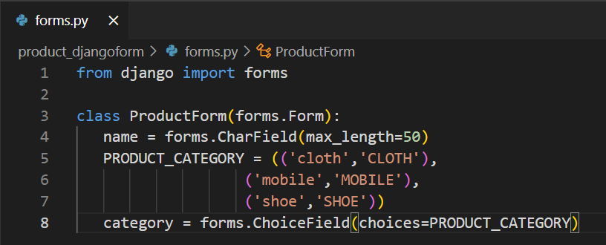

* 1. Create view to display above form

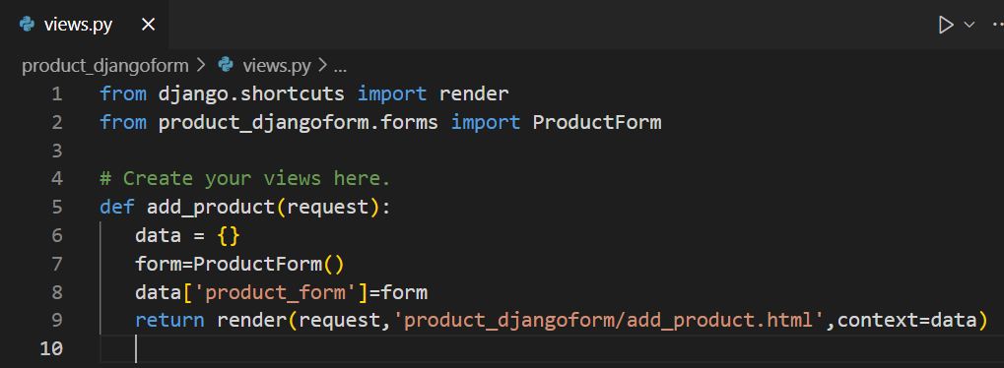

* 1. Display form in templates > product_djangoform > add_product.html

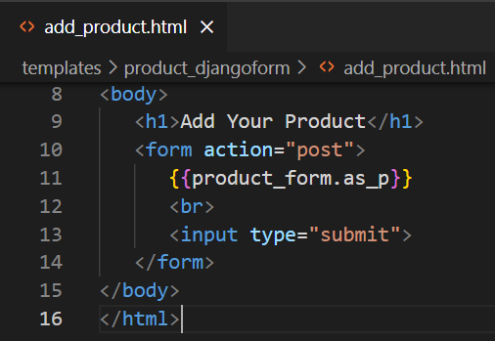

* 1. Create application level url
     1. Create product_urls.py in product_djangoform

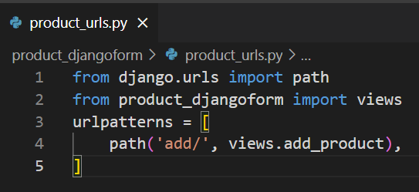

* 1. Register above application level url in urls.py

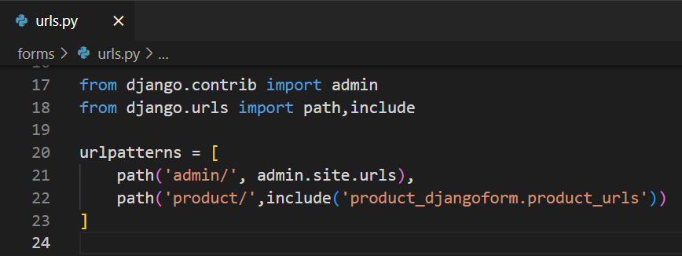

* 1. Output :

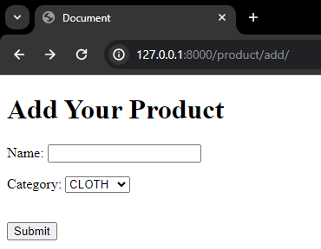

1. Inserting django forms data into table :
   1. Add csrf_token into form

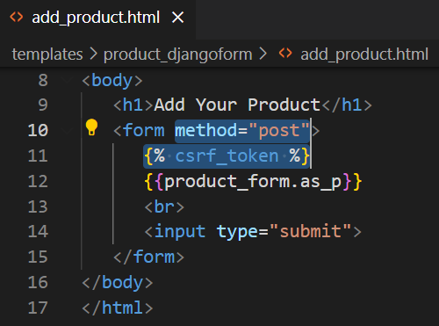

* 1. Collect data from form and insert into table (model) [views.py of product_djangoform]

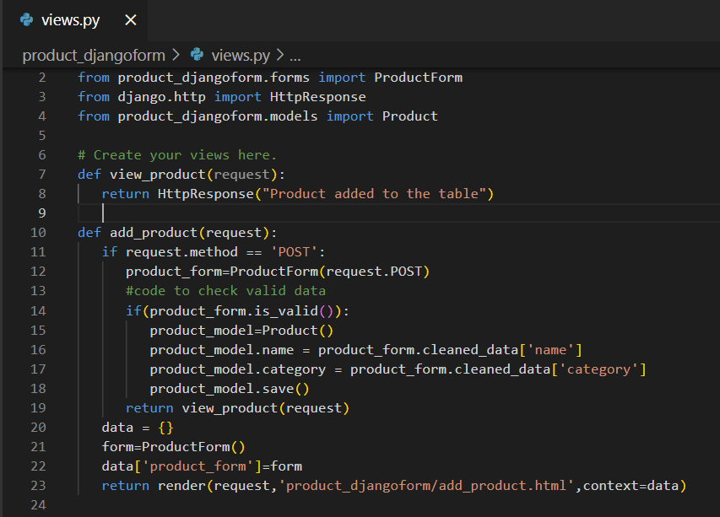

* 1. Output

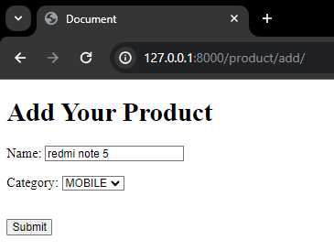 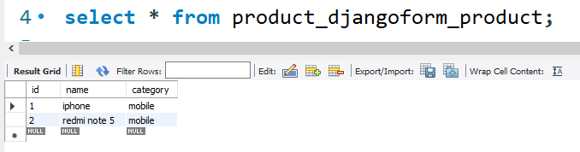

1. Working with model form (here we will use our movie_modelform application)



* 1. Create forms.py in movie_modelform. Code –

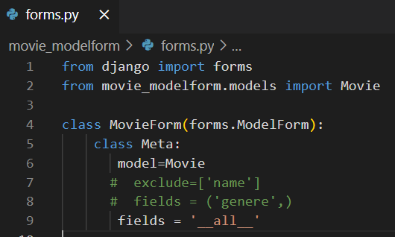

* 1. Create view to show above model form (views.py in movie_modelform)

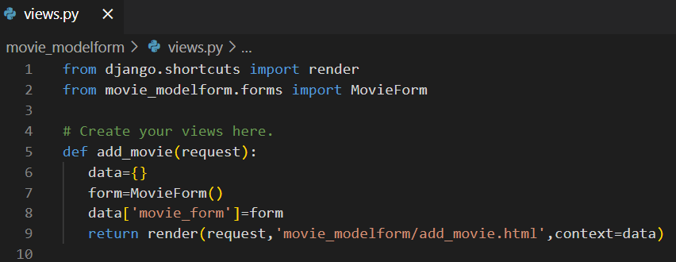

* 1. Display form in templates > movie_modelform > add_movie.html

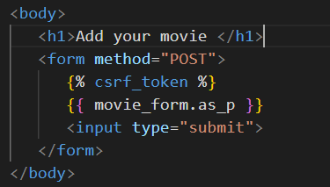

* 1. Create movie_urls.py in movie_modelform

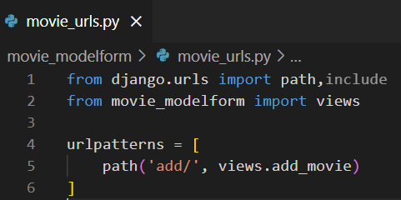

* 1. Register above movie_urls.py in urls.py

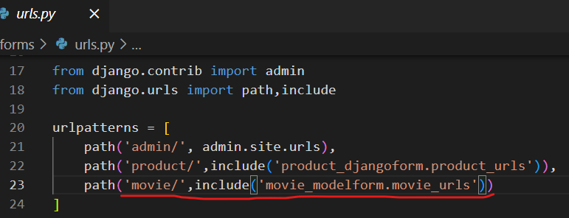

* 1. Visit url and check form

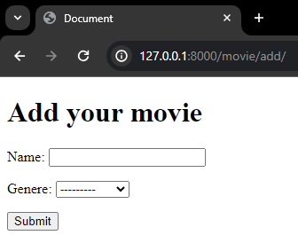

* 1. Logic to insert data into table

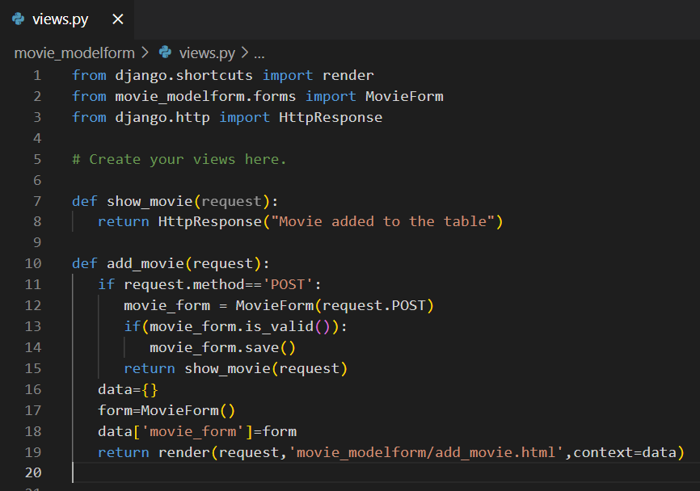

* 1. Output

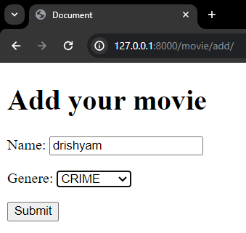 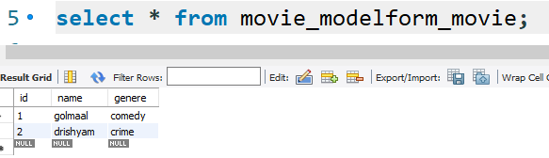

* 1. DONE!

1. Working with general form



No need to create forms.py since we are creating general form

* 1. Create view to display form (views.py of user_generalform)

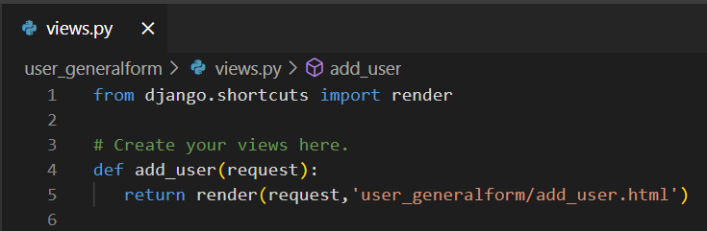

* 1. Code to display form (templates > user_gerenalform > add_user.html)

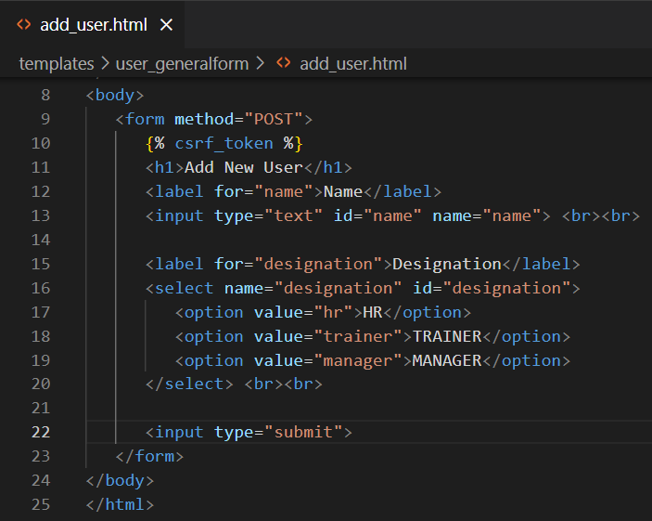

* 1. Create user_urls.py (user_gerenalform > user_urls.py) to create application level url

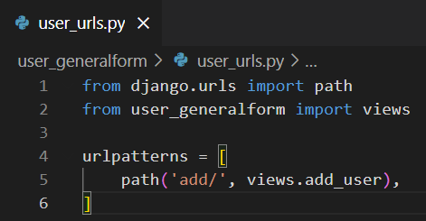

* 1. Register above user_urls.py in urls.py

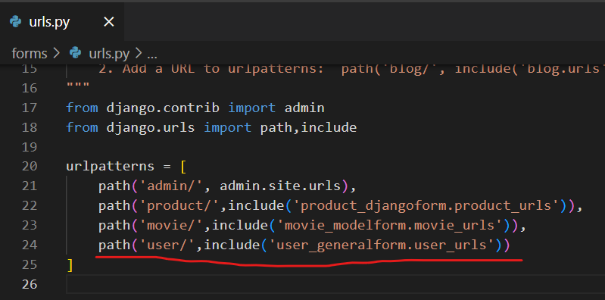

* 1. Check output

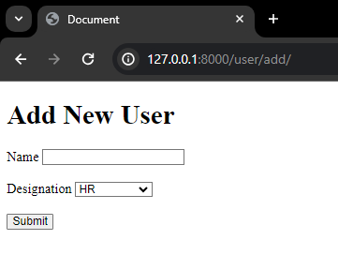

* 1. Code to insert data into table (update views.py)

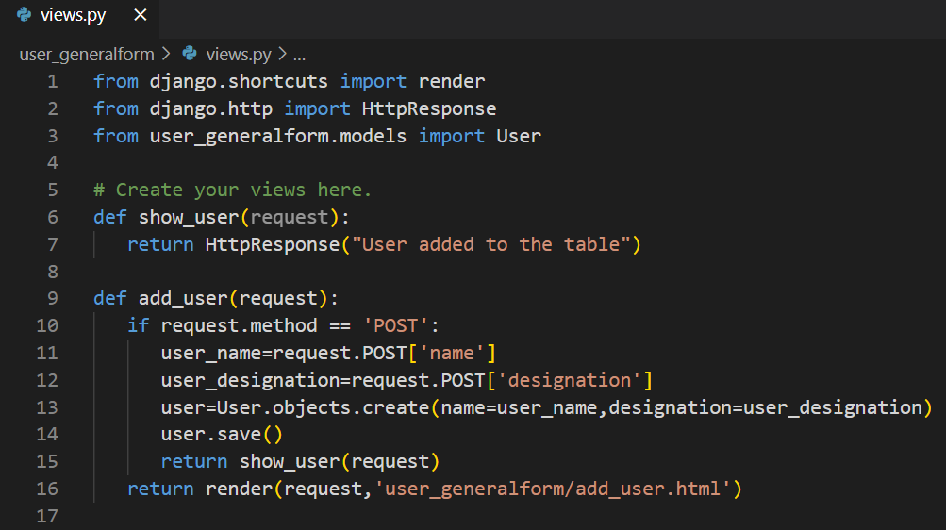

* 1. Output

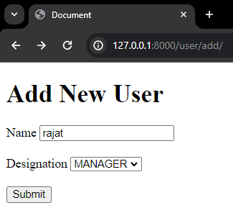 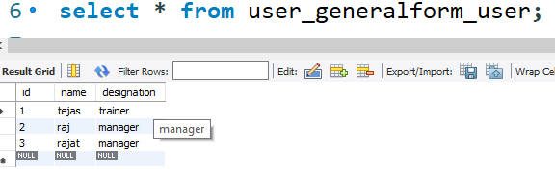

1. FORM DONE !!!!!!!!!!!!!!!!!!!!!!!